MARCH 2025 ELECTRONIC EDITION #1

#### **The Squeaky Squirrel**

The Sampson Community Club’s newsletter

About and for our mountain community, produced by kim vantrease

Sampson Community Club16150 Sampson Road, Littleton, CO 80127  Facebook.com/SampsonCommunityClub OR [WWW.SAMPSONCLUB.ORG](http://WWW.SAMPSONCLUB.ORG)

At SAMPSON COMMUNITY CLUB 16150 SAMPSON ROAD, LITTLETON, CO

**Bingo Fundraiser on MARCH 29TH - FUN BEGINS at 4:00 PM**

More about Bingo on *Page 3* of this Issue!

**Mountain Mama Breakfast on May 10th** - 9:00 AM to 11:00 AM Calling all Moms! Come to the Sampson Community Club to celebrate YOUR day with a scrumptious breakfast cooked and served by family chefs. Enjoy a morning of relaxation with your family and friends. We look forward to celebrating with you! Because this was such a popular event last year, we want to have some more fun this year! All moms need a break! Come on down with your family and enjoy what we have prepared just for you! Feel free to contact any Board Member if you would like more information about this event. See ya there!

**MOVIE NIGHT UNDER THE STARS ON THE GIANT SCREEN JUNE 6TH @ 8:15 PM** Movie to be determined later; check the website and Facebook page for updates or cancellations due to inclement weather. Bring a comfy chair (or use one of the club’s chairs) something warm to wear, and your favorite movie munchies!

**ICE CREAM SOCIAL JUNE 21ST @ 2 PM** You know what’s better than eating ice cream? Eating it with your family, friends and neighbors! Grab everyone, even Uncle Poindexter, and come on down for the annual ice cream social! This long-cherished event wouldn’t be complete without home-made ice cream and all the fixins! Show off your ice cream-making skills and impress your neighbors. Bring your home-made ice cream (or store bought) to the Sampson Community Club and gather round. The Sampson Club will provide the rest of the goodies for all the fabulous ice cream creations!

**MOVIE NIGHT UNDER THE STARS ON THE GIANT SCREEN JULY 11TH @ 8:15 PM** Movie to be determined later; check the website and Facebook page for updates or cancellations due to inclement weather. Bring a comfy chair (or use one of the club’s chairs) something warm to wear, and your favorite movie munchies!

**MOVIE NIGHT UNDER THE STARS ON THE GIANT SCREEN AUGUST 8TH @ 8 PM** Movie to be determined later; check the website and Facebook page for updates or cancellations due to inclement weather. Bring a comfy chair (or use one of the club’s chairs) something warm to wear, and your favorite movie munchies!

**ANNUAL PIG ROAST AND 100-YEAR CELEBRATION SEPTEMBER 13TH** The festivities kick off at noon! Bring your favorite side dish to share and enjoy a feast with your friends and neighbors. This is another treasured event that has continued for many years, and we will also celebrate the 100th year of this beloved building! Bring yourselves down and meet others in your community. We always have a great time hanging out, playing games, and meeting new people. If you have any questions about this event, please contact any of the Board Members or write to sampsoncommunityclub.org. This favorite fundraiser is only $15.00 per family or $8.00 per person; extra donations are always welcomed. Donations received are put toward the betterment of the Sampson Community Club Building and events. Because it is a celebration of the building’s 100th year, we’ll have more games and prizes this year!! Woot! *Oink…*

**CHILI COOK-OFF OCTOBER 18TH @ AT 5 PM** Bring a pot of your homemade chili to share among the crowd. Together, let’s pick the winners at the Chili Cookoff! Don’t have time to make chili? No problem, come on down anyway and enjoy a bowl of chili and help decide the winners! Donations always welcome, but don’t worry, we won’t shake ya down for cash.

**ANNUAL MEMBERSHIP THANKSGIVING DINNER NOVEMBER 8TH @ 3 PM** The Sampson Community Club provides the turkey, and everyone is invited to bring a side dish. This is a good time to experiment with new holiday recipes on your friends and neighbors. Office of Vice President and Treasurer are up for election/re-election this year. Have ideas about events at the Sampson Community Club? Bring them! Let’s discuss opportunities and new events as we fellowship among neighbors. We invite you all to join in the fun again this year!

**Every Wednesday Evening at 6:30 PM - Bible Study Offered by Deer Creek Canyon Bible Church**. All welcome to come anytime! Come as you are! Questions? Feel free to email Pastor Bob at **deercreekcanyonbiblechurch.org** and click the **Contact Us** tab. Fellowship begins at 6:30 to 7:00, which includes a table of snacks, coffee/hot chocolate and then the teaching begins at 7. So, if you can’t get there by 6:30, you can still make the lesson. Deer Creek Canyon Bible Church rents space from the Sampson Community Club to provide weekly Bible teachings for those in the community who are interested [www.deercreekcanyonbiblechurch.org](http://www.deercreekcanyonbiblechurch.org).

**End of Calendar of Events but always check website and**

**Facebook pages for new events or cancellations.**

**THIS IS OUR FIRST ELECTRONIC SQUEAKY SQUIRREL NEWSLETTER…**

We appreciate your support and hope you like this new version! The Squeaky Squirrel will always be available online for your perusal at [**www.sampsonclub.org**](http://www.sampsonclub.org). Remember, if you would like it emailed to you, please contact us at [sampsoncommunityclub@gmail.com](mailto:sampsoncommunityclub@gmail.com) and let us know. If you want a paper copy because you have limited access to the internet, please text or call Kim at **303-570-9028** and advise her of your desire to receive the Squirrel via postal delivery.

We really didn’t want to change our long-time tradition of mailing copies, but postage has become quite a significant matter these days. Thank you for your understanding and interest in our local Newsletter. Feel free to let us know if you do not receive your emailed copy in March; we want to make sure you all get your copy!

NOW, about that BINGO Night on **MARCH 29 AT 4 PM!** This fundraiser is sure to be a lot of fun. Bring the gang to the Sampson Community Club at 16150 Sampson Road! We’ll play 8 games of Bingo with prizes! The suggested donation is (but not limited to) $15 for a complete set of Bingo cards. More packets are available if you like a challenge! Concessions are available, too! Donations are gladly accepted as proceeds go toward the necessary maintenance for the schoolhouse building. Speaking of this building, the Sampson School building is 100 years old this year! We’ll be recognizing this milestone at this year’s Annual Pig Roast! Lots of fun in store for that, too!.... *B-4, 0-75, N-34…* ***B I N G O!!!!***

**FIRE INFORMATION FOR HOMEOWNERS:**

On March 1st, our local Fire Ambassadors Katrina Stevens and Jennifer Rich, held a Fire Meeting at the Sampson Community Club that was packed with information for area residents. Below are Katrina’s notes regarding that meeting. There will be more to come in future postings. Thank you, Katrina and Jennifer!

“First, a big thank you to the 40(!) people who came to the Fire Meeting on March 1st at the schoolhouse. It was an awesome turnout and there was a ton of information. I am working on condensing 3 hours of presentations down into a manageable number of pages. Attached is Part 1.

Captain John Mandl, Wildland Captain for Conifer Fire District, spoke at length about changes at the fire district, including the recent unification of Inter-Canyon and North Fork Fire Districts, and changes to this year's Chipping Program. As you'll see in the notes, the chipping program will be reduced this year and will target properties that have completed a Wildfire Prepared Home Assessment. If you have not had an assessment, or if you do not get selected in the lottery, don't be discouraged from mitigating. I will be reaching out to organize a community chipping event and/or some other way of getting rid of your slash.

In the meantime, I strongly recommend getting a Home Assessment. Not only will it make you eligible for future chipping (if the program stays the same for 2026 - not a guarantee), but you will also learn exactly what efforts will make your particular property more resilient to wildfire. The link to sign up is included in the notes.

So much more to come. As always, please reach out with any questions.

Thanks,

Katrina Stevens

303-249-0989

kt4kt@aol.com

[maxwellareacap@gmail.com](mailto:maxwellareacap@gmail.com)”

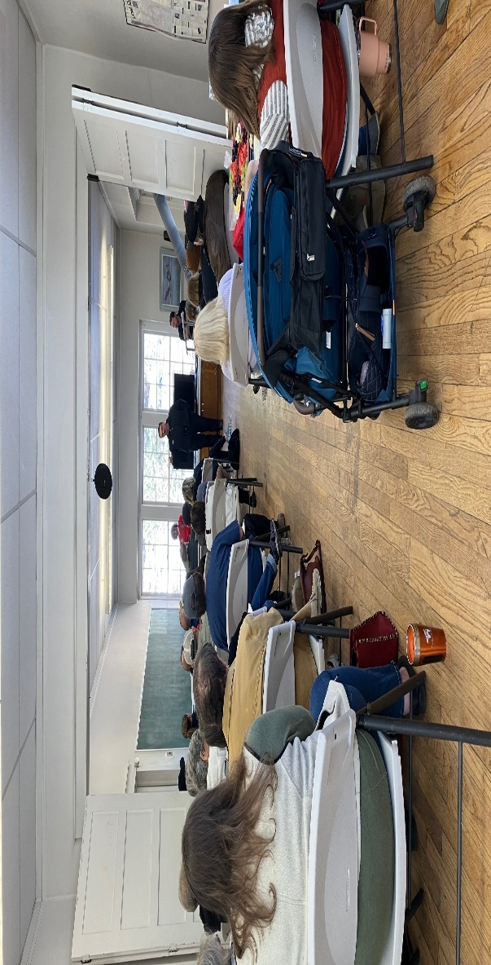

**RECENT EVENTS**:

*Contributed by Kim Vantrease*

Recently, the Sampson Community Club building was rented out for a Sacred Drum Crafting Experience. Tiffany Grimm Fulton, Aaron Fulton, Jr., and Joe Drake hosted, sharing their knowledge and abilities. A video and pics are provided below. The drums were created from ethically sourced bison and they all turned out great! Enjoy!



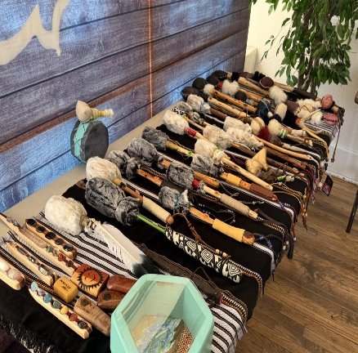

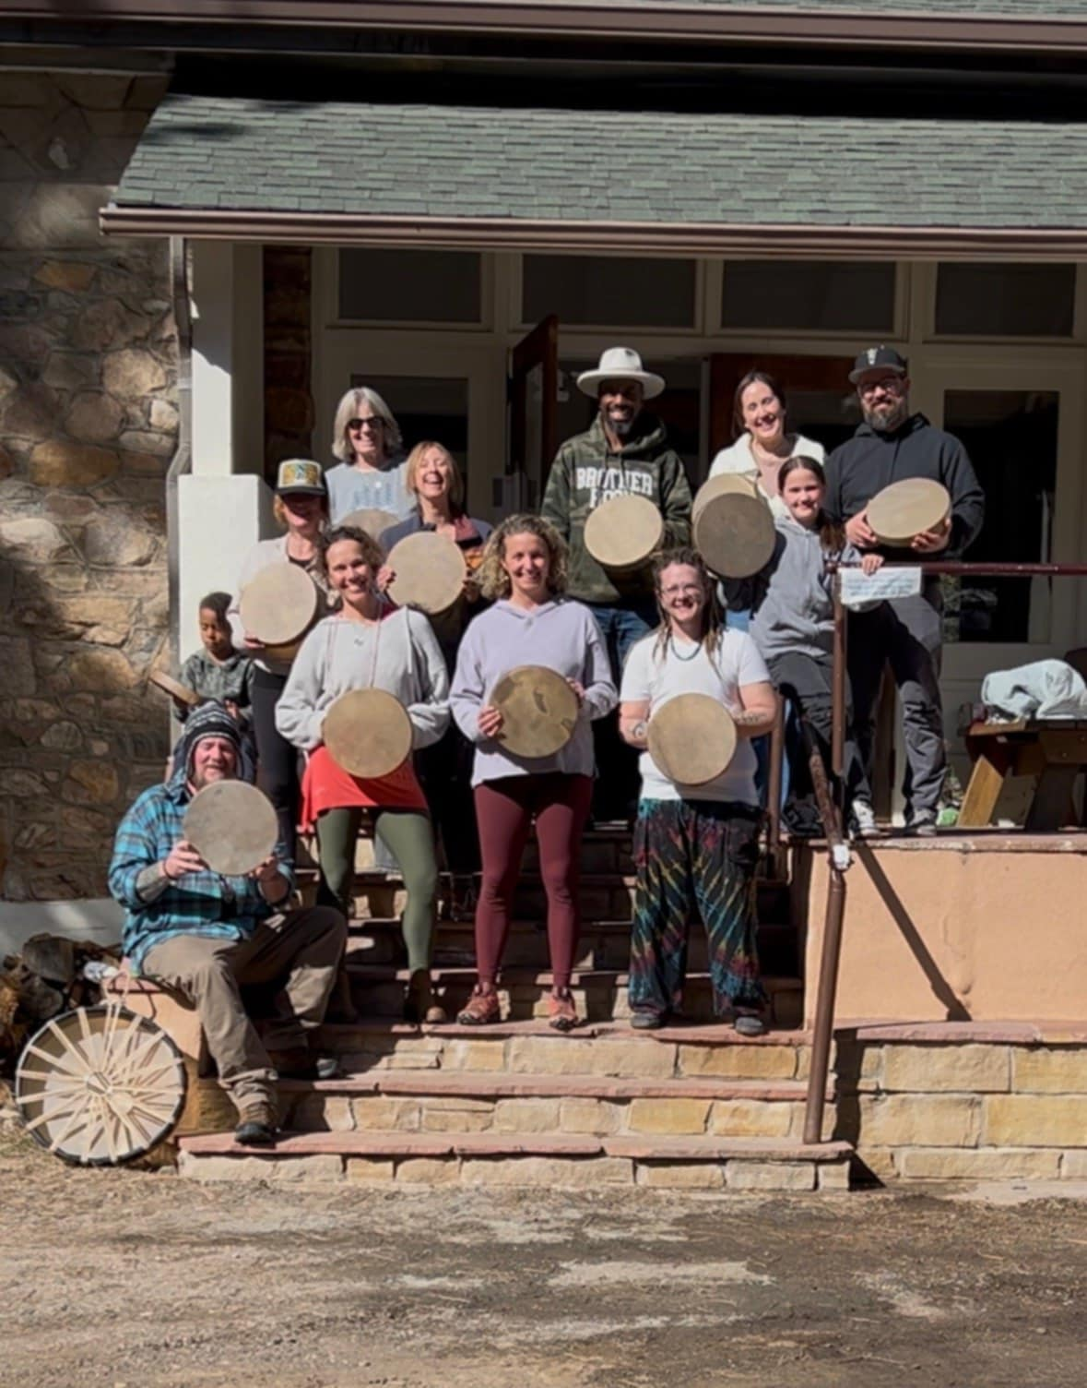

**MEMBERSHIP**: Thinking about becoming a member? Annual Membership is just $20.00. As a member, you are under no obligation to commit to volunteering. Some folks shy away from community membership as they think they may be obligated to certain commitments, but that’s not the case here. Of course, we’d never turn down offers of volunteerism or cash donations as they do contribute to the care and maintenance of the Sampson School Building. We just want to provide the best community center for you; this hub is here for you and offers many benefits to the community.

If you are new to the area and want to become a member of the Sampson Community Club, or if you haven’t renewed your membership yet, you can mail $20.00 dues to 16150 Sampson Road, Littleton, CO 80127. There are Membership Forms on the **sampsonclub.org website**, or in a red folder on the front porch of the Sampson School. There is always something going on at the Sampson Community Club, so be sure to check out all the happenings in the community at [**www.sampsonclub.org**](http://www.sampsonclub.org/) and **Facebook.com/sampsoncommunityclub**.



**WITH SINCERE GRATITUDE**

*Contributed by Kim Vantrease*

Your time and energy spent helping the Sampson Community Club is highly appreciated. You all really do make a difference and our community is better because of you, so thank you! Throughout the year, community members volunteer their time in helping with maintenance tasks etc., thank you! Also, thank you, Sampson Road residents, for plowing the Sampson Club parking lot! With so many events going on throughout the year, it really helps to have the snow plowed. Thank you, Deer Creek Canyon Bible Church, for cleaning the Sampson School on a weekly basis and always pitching in for the care and maintenance of the building. It’s amazing when people come together; there are just so many benefits associated. We extend a huge thanks for all of your volunteered time, monetary donations, participation, donated items, firewood, muscle, shoveling/plowing, hosting, planning, etc!

Working together and helping others in the community makes us grow and thrive. It’s definitely a rewarding experience for all involved. We are always so grateful to our event hosts, coordinators, volunteers, those who attend the events, and the Board for bringing this community together. And thank you, Mitch Tanenbaum for printing the “Squeaky Squirrel” those many years. I will miss our email chats! Thanks to all for your support in 2024! Can’t wait to see what 2025 brings us!!!

**Remember, events will be on the website at** [**www.sampsonclub.org**](http://www.sampsonclub.org) **or Facebook.com/SampsonCommunityClub. Check for updates & new events that may be added or cancelled**!

**QUICK CONTACT REFERENCE - SAMPSON COMMUNITY CLUB BOARD MEMBERS**

President, Kim Vantrease, valleyhawk7@msn.com 303-681-2104 or text 303-570-9028

Vice President, Bryn Shepeck, shepeckbryn16@gmail.com 720-499-6347

Treasurer, Kari Vernon, karikvernon@gmail.com 303-697-6700

Secretary, Amanda Dougherty, imactingup21@hotmail.com 303-903-1918

www.sampsonclub.org -- facebook.com/sampsoncommunityclub - sampsoncommunityclub@gmail.com

**SAMPSON COMMUNITY CLUB GARDEN**

Currently, there are two garden spaces left to use at the Sampson Community Club garden. The spaces are about 20’ x 20’ and cost $40.00 per year to use. Water from the well is available for your use in your garden. Contact us through [sampsoncommunityclub@gmail.com](mailto:sampsoncommunityclub@gmail.com) to reserve your space now!



**FOR** **NEW RESIDENTS---DID YOU KNOW?**

*Contributed by Kim Vantrease*

Lots of people don’t realize that the Sampson Community Club is for everyone. It’s a community center and isn’t exclusive to Sampson Road residents like many have thought. It’s for you and serves as a main hub where folks can gather for fun events, make new friends, learn about the area, volunteer, exchange important information, carpool opportunities; just too many perks to list! Remember, this community hub is here for you! And don’t forget, you can rent the building for your own personal use. Lots of people have been renting the building this past year realizing just how handy it is! Another bonus is, you can borrow tables and chairs to use at your home for events. Sampson Community Club Members will pay $30.00 per day to rent the schoolhouse, and nonmembers will pay $50.00 per day. We also offer special weekly rates, as well. If you would like to rent the Sampson School House Building, contact any of the Board members as they would be happy to get you on the schedule. The Club is tax exempt as a 501(c)(4) organization. According to the IRS, all donations to the Club are not tax deductible by the donor. As always, all are welcome to attend the Club functions! We look forward to meeting you! C’mon and join the fun!

**JEFFERSON COUNTY SLASH PROGRAM 2025 LINK:**  <https://www.jeffco.us/2493/Slash-Collection>

**WILDLIFE:**

The bears have sprung from their cozy dens and are hungry. Remember to keep trash secure as we don’t want to get our bears arrested or worse…euthanized! Also, little fawns will be roaming on their wobbly legs and following their mamas around. Keep a watchful eye out for these naïve creatures in the roadways! 



**COMING SOON!**

*Contributed by Kim Vantrease*

Coming soon to the Sampson Community Club. We are in the beginning stages of developing a community-wide puzzle exchange! It will work just like the Little Library book exchange located at the east side of the Sampson School building. So don’t toss those used puzzles yet, instead, exchange them for a different one at the Sampson Community Club. AND, speaking of book exchange, don’t forget to take advantage of that as well! We’ll update you when the Puzzle Exchange has been completed! If you have any questions, please feel free to contact us at [sampsoncommunityclub@gmail.com](mailto:sampsoncommunityclub@gmail.com).





Well, that’s all for now in this issue of the Squeaky Squirrel. Thanks for reading and we’ll see you soon!