MC900351349[1]

#### **The Squeaky Squirrel**

The Sampson Community Club’s newsletter

About and for our mountain community, produced by kim vantrease

Sampson Community Club16150 Sampson Road, Littleton, CO 80127  Facebook.com/SampsonCommunityClub OR [WWW.SAMPSONCLUB.ORG](http://WWW.SAMPSONCLUB.ORG)

**UPCOMING EVENTS!**



**OCTOBER 7, 2023 – CHILI COOKOFF @ 5:00 PM!** Details on *Page 2*

**NOVEMBER 11, 2023 - THANKSGIVING MEMBERSHIP DINNER @ 3:00 PM**

***PLEASE NOTE: TIME HAS CHANGED TO 3 PM.*** Details on *Page 2*

**SUPER BOWL WATCH PARTY ON BIG SCREEN TV'S - THE FUN BEGINS @ 4 PM! (*JUST ADDED!)***

We had so much fun last time that we're doing it again! Football Bingo will return as well as prizes! FUN! Bring your favorite football munchie you'd like to share. The Sampson Club will provide drinks and some other snacks as well! You can bring your camping chair or use the club's chairs. Join us for some good ole fashioned football! *Watch for any updates at www.sampsonclub.org and facebook.com/sampsoncommunityclub.*

**POKER NIGHT IS COMING!** Poker players, email me at valleyhawk7@msn.com if interested. And keep an eye on the www.sampsonclub.org website for information and updates!



**♥COMMUNITY NEEDS**

If you know somebody in the community who has recently lost a spouse or experienced another tragedy, just let us know and we’ll bring them a warm meal or a pick-me-up basket of goodies. We would like to share our community support with our neighbors in need.

**2023 CALENDAR OF EVENTS**

**AT SAMPSON COMMUNITY CLUB**

**EVERY WEDNESDAY at 6:30 PM – BIBLE STUDY AT THE SAMPSON COMMUNITY CLUB**

All welcome to come anytime! Come as you are or when you feel that tugging in your heart. If you have questions, feel free to email Pastor Bob at **deercreekcanyonbiblechurch.org** and click the **Contact Us** tab. We fellowship from 6:30 to 7:00, which includes a table of snacks, coffee/hot chocolate and then the teaching begins at 7. So, if you can’t get there by 6:30, you can still make the lesson. Deer Creek Canyon Bible Church only rents space from Sampson Community Club and is not a part of the Sampson Community Club. [www.deercreekcanyonbiblechurch.org](http://www.deercreekcanyonbiblechurch.org).

**OCTOBER 7, 2023 – CHILI COOKOFF @ 5:00 PM!**



Bring a pot of your homemade chili and share among the hungry tasters. Let’s pick a winner to hold the Chili Cookoff title for 2023! Hope you can join in this fun fall event. Don’t have time to make chili? No problem, come on down anyway and enjoy a bowl of chili and you can help decide who wins! Donations always welcome!

**NOVEMBER 11, 2023 - THANKSGIVING MEMBERSHIP DINNER @ 3:00 PM**

***PLEASE NOTE: TIME HAS CHANGED TO 3 PM.***

The Sampson Community Club provides the turkey, and everyone is invited to bring a side dish to share. This is a fun time to experiment with new holiday recipes on your friends and neighbors. Offices of Vice President and Treasurer are up for election/re-election this year. Holley Frederick has served this community for several years and has recently moved away. Her office of Vice President will be vacant come November. Bring your appetites and ideas about future events for the Sampson Community Club. As always, all are invited to join in the fun! Members can run for an office and/or vote.

**SUPER BOWL WATCH PARTY - THE FUN BEGINS @ 4 PM! DATE TBD -WATCH WEBSITE FOR INFO!**

**\* * \***

**DID YOU KNOW?**

*Contributed by Kim Vantrease*

Many people think the Sampson Community Club is exclusive to Sampson Road residents. Nope, this is a community center for all. It's good to have this main hub where folks can gather, make new friends, learn about the area, get important information, carpool opportunities, borrow tables and chairs for personal events…the perks just go on and on. 😊 Remember, this community hub is for you!

**WELCOME…**

If you are new to the area and curious about the happenings at The Sampson Community Club, or want to join in the action, just reach out to one of the Board Members and they would be happy to answer any of your questions. Membership is just $20.00 per year and renews every December 1st. Internet is available at the schoolhouse for members to use. With your new/renewed membership, you will get the internet password for your personal use. Contact us about getting a Membership Form to you or you can pick one up at the Sampson Community Club on the front porch in a red folder. *As a Member of the Sampson Community Club, you’re never obligated to volunteer for events or fundraisers. It’s just up to anyone who would like to volunteer their time. Members or nonmembers always welcome to participate!*

***IMPORTANT NOTE:*** *Throughout the year, events may be cancelled and events may* ***be added*** *that are not listed on the current Calendar of Events, so please be sure to check often for new events or other important updates at* ***Facebook.com/SampsonCommunityClub and*** [***www.Sampsonclub.org***](http://www.Sampsonclub.org)***.***

**WITH** **CONTINUED APPRECIATION**

*Contributed by Kim Vantrease*

The Sampson Community Club sincerely appreciates your time, energy, and monetary donations. Working together and helping others makes us grow and thrive. We are so grateful to our event hosts, coordinators, volunteers, those who attend the events, and board members for bringing this community together. Also, thanks to Mitch Tanenbaum for printing the “Squeaky Squirrel” as well as the event fliers and e-mail blasting the Sampson Community Club's announcements. You all really do make a difference and our community is better because of you! Thank you for all your support in 2023!

Just an FYI, the Sampson Community Club uses Sampson School for its events, so if a neighbor invites you to the Sampson Community Club or the "community center" for an event, they are talking about Sampson School, which is located at 16150 Sampson Road. Internet is also available for members. With your new/renewed membership, you will get the internet password for your personal use.

The Club is tax exempt as a 501(c)(4) organization. 501(c)(3) organizations are the only ones where your donations are tax deductible on your personal income tax. According to the IRS, all donations to the Club are not tax deductible by the donor. As always, all are welcome to attend the Club functions! We look forward to meeting you! C’mon and join the fun!

**CHECK OUT OUR LOCAL BUSINESSES!**

**ADDITIONAL THANKS TO…**

*Contributed by Kim Vantrease*

Don Coenen, your music, your voice, your talent! We are truly fortunate to have you in our community. We always enjoy your music at the Annual Ice Cream social. Thank you so much for sharing your abilities with us and making events so special for us. You are a treasure! ♩♩♩

Kurt Hopkins held his father's memorial service at the Sampson Community Club this past June. His father, Lew Hopkins, attended Sampson School from 1936 to 1944 and was the only graduate in his 8th grade class. Kurt donated cash, Sampson School effects, historical accounts of the ski runs in the area, a poster of the old ski runs, and a school bell. These items are highly appreciated and are on display at the Sampson Community Club. Every time I'm in this old Sampson School building, I wonder what school would have been like back then. I think I would have loved it.

This summer, a good neighbor did some weed eating at the Sampson Community Club property. While nobody saw who did this welcomed deed, the evidence was clear. So, thank you, good neighbor, for helping with the maintenance! Your kindness is deeply valued.

We'd like to thank John and Sue Dowd for their donation of a new shelter canopy, tons of soda and other items to the Sampson Community Club! Your generosity is most welcomed!

We are happy to announce that nobody will freeze this year at the Sampson Community Club! We were able to collect enough firewood to take us through the winter! Thank you, Eric Belt, Gena Williams, and Brien and Gigi Schlomer for your generous donations of firewood!

Thank you, Pastor Bob O'Fee, for the beautiful woodwork décor you have created and donated!

**WE WOULD LOVE TO HEAR FROM YOU**

*Contributed by Kim Vantrease*

If you have photos or a story, present day, or history about the community, we'd love to hear from you. Submit to me at valleyhawk7@msn.com

**HOMESCHOOL AND OTHER SCHOOL HAPPENINGS**

*Contributed by Amanda Dougherty*

 There's still time to register for The Venue's Homeschool Theater class. Class time runs Tuesdays from 11:00 a.m. to 12:30 p.m. Registration ends before the end of September!

This December, The Venue Theatre in Conifer Presents *Chicago.* Tickets and other information can be found at **www.thevenuetheatre.com**.

Conifer High School will be presenting their fall play, *Check Please*, on November 10th and 11th*.* More info at 303-982-5255 or www.jeffcopublicschools.org.Enjoy a night out and support our local youth!

**OUR V.P. HAS MOVED AWAY**

*Contributed by Kim Vantrease*

Recently, Holley and her family bought a house and moved away. We have thoroughly enjoyed Holley's support over the years at the Sampson Community Club. Her volunteering and children's activities have been great for this community. We are truly going to miss Holley's genuine kindness and smiles around here. Her kiddos will be missed as well. While we're thrilled for their new adventures, we are truly going to miss this precious family. Thank you, Holley, for all you have done for this community! We wish you all the best.

***Since Holley has moved, her office of Vice President will become vacant this November 11th and up for election. Contact any of the Board Members if you'd like more information about this office.

**ICE CREAM SOCIAL**

*Contributed by Kim Vantrease*

This past July, we held the annual Ice Cream Social with *the* best live music by Don Coenen. Always a really good time kicking back over a bowl of ice cream with friends as good music fills the room. This is always a special day for the community. Two tables were loaded with various kinds of ice cream and all the *fixins*; it was amazing. Recently, we've had some requests to possibly place the Ice Cream Social a bit earlier on the calendar as summer plans for families fill up quickly. Many wanted to attend, but couldn't due to other commitments. We'll definitely consider this request! Thank you, Don, for your wonderful music and thank you, Kari and Trevor Vernon for assisting in hosting this cherished event!

*If you would you prefer to receive the Squeaky Squirrel electronically, please contact Mitch Tanenbaum at mitch@mtanenbaum.us. Color version through email! Also, check out the website* [*www.sampsonclub.org*](http://www.sampsonclub.org)*.*

**FYI:** The Squeaky Squirrel arrives early on the website at [**www.sampsonclub.org**](http://www.sampsonclub.org). So, if you’re wanting to check it out earlier than normal, just head over to the website and look under the Squeaky Squirrel Page.

**PIG ROAST**

*Contributed by Kim Vantrease*

The Annual Pig Roast was held last month. We had quite a crowd this year and I heard many say it was the biggest gathering they can remember. Lots of new and familiar faces came to enjoy the day. I really enjoyed seeing old friends and meeting new ones. Lots of friendships and networking sprout from these events. Our hosts who tended the pig were Joe, Hannah, and Bryn Shepeck. They always make this treasured event exceptional. Thank you, Joe, Hannah and Bryn; we all had a really great time! This year we had several games, prizes and door prizes. Fun! You should see what we have in store for next year! Thank you, Kari and Trevor Vernon, and Amanda and Greg Dougherty for all your assistance for this event.

Joe, Hannah and Bryn

Noemi arrives in style!

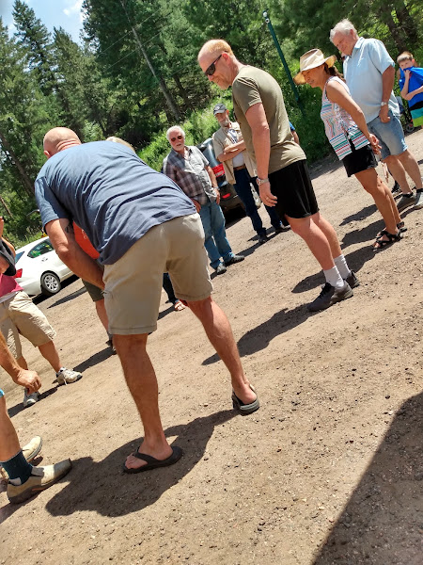

*FIND MORE PHOTOS OF THE PIG ROAST @ WWW.SAMPSONCLUB.ORG UNDER EVENT PHOTOS*!

**YOUR SAMPSON COMMUNITY CLUB BOARD**

President, Kim Vantrease, [valleyhawk7@msn.com](mailto:valleyhawk7@msn.com) 303-681-2104 or text 303-570-9028

Vice President, Holley Frederick [holleyhuggins@gmail.com](mailto:holleyhuggins@gmail.com) 720-233-4869

Treasurer, Kari Vernon, [karikvernon@gmail.com](mailto:karikvernon@gmail.com) 303-697-6700

Secretary, Amanda Dougherty, [imactingup21@hotmail.com](mailto:imactingup21@hotmail.com) 303-903-1918



From our families to yours, the Sampson Community Club Board would like to wish you all a Happy Thanksgiving where lasting memories are made with your loved ones as you take this special day to reflect on all your blessings.

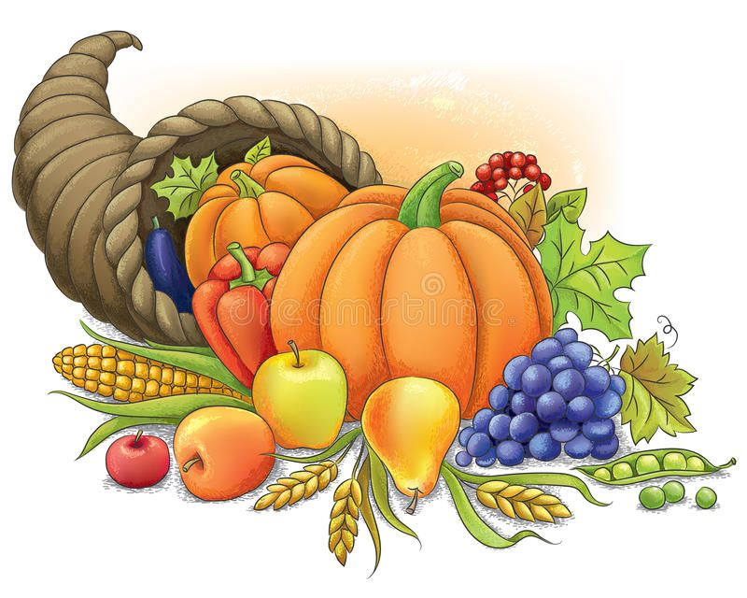

The Sampson Community Club

16150 Sampson Road

Littleton, CO 80127



**EVENTS AT SAMPSON COMMUNITY CLUB *AT A GLANCE***

BIBLE STUDY EVERY WEDNESDAY NIGHT 6:30 PM

CHILI COOK-OFF OCTOBER 7TH  5 PM

THANKSGIVING MEMBERSHIP NOVEMBER 11 at 3 PM (Note: Time has changed to 3 PM)

SUPER BOWL WATCH PARTY - THE FUN BEGINS @ 4 PM! DATE TBD -WATCH WEBSITE FOR INFO!

POKER IS COMING - DATE/TIME TBD!

*BE SURE TO CHECK* ***Facebook.com/SampsonCommunityClub*** *OR* [***WWW.SAMPSONCLUB.ORG***](http://WWW.SAMPSONCLUB.ORG) *FOR* ***UPDATES*** *ON EVENTS OR RECENTLY* ***ADDED*** *EVENTS*